# **Department of Computer Science and Engineering Islamic University of Technology (IUT)** A subsidiary organ of OIC

# **Lab Report 04**

# CSE 4512: Computer Networks Lab

## 

## **Name :** Abdullah **Student ID :** 200041126 **Section :** 1B **Semester :** WINTER (5th) **Academic Year :** 2022-23

**Date of Submission :** 18-09-2023

### **Title:** Configuring Switch Port Security and Switch Port Analyzer (SPAN) in Cisco Devices

### **Objective**:

1. Describe the concept of Switch Port Security
2. Explain importance of Switch Port Security in securing an organization
3. Configure Switch Port Security in CISCO devices
4. Use Switch Port Security feature to achieve varying degrees of protection
5. Describe the concept of port mirroring
6. Implement port mirroring using Cisco Switch Port Analyzer (SPAN)
7. Explain use cases of SPAN in real-life

### 

### **Devices/ software Used**:

* + - 1. Laptop
      2. Cisco Packet Tracer Software

### **Theory:**

**Port Mirroring:**

Port Mirroring, also known as SPAN (Switch Port Analyzer) or RSPAN (Remote SPAN), is a technique used to copy network traffic from one or more source ports on a network switch and send it to a designated monitoring port. This monitoring port is connected to a network analyzer or packet capture device, such as a network sniffer or intrusion detection system.

The key points about Port Mirroring are:

* **Purpose**: Port Mirroring is primarily used for network analysis, monitoring, and troubleshooting. It allows network administrators to inspect traffic for performance optimization and security analysis.
* **Configuration**: In Port Mirroring, administrators configure the switch to copy traffic from selected source ports (which can be individual ports, VLANs, or entire interfaces) to the monitoring port.
* **Local vs. Remote**: Local Port Mirroring refers to copying traffic within the same switch, whereas Remote SPAN extends this capability to switches in different parts of the network.
* **Usage**: Port Mirroring is valuable for various purposes, including network troubleshooting, intrusion detection, traffic analysis, and compliance monitoring.

**Local SPAN:**

Local SPAN is a specific implementation of Port Mirroring that focuses on monitoring traffic within a single network switch. It involves copying traffic from specific source ports within the same switch to a designated monitoring port on the same switch.

The key points about Local SPAN are:

* **Scope**: Local SPAN is limited to the switch it is configured on, and it allows monitoring of traffic within that particular switch.
* **Simplicity**: It is relatively easier to set up compared to Remote SPAN because it doesn't involve multiple switches.
* **Use Cases**: Local SPAN is commonly used for tasks like monitoring network performance, troubleshooting local network issues, and analyzing traffic for security purposes within the boundaries of a single switch.

### **Diagram of the experiment(s):**

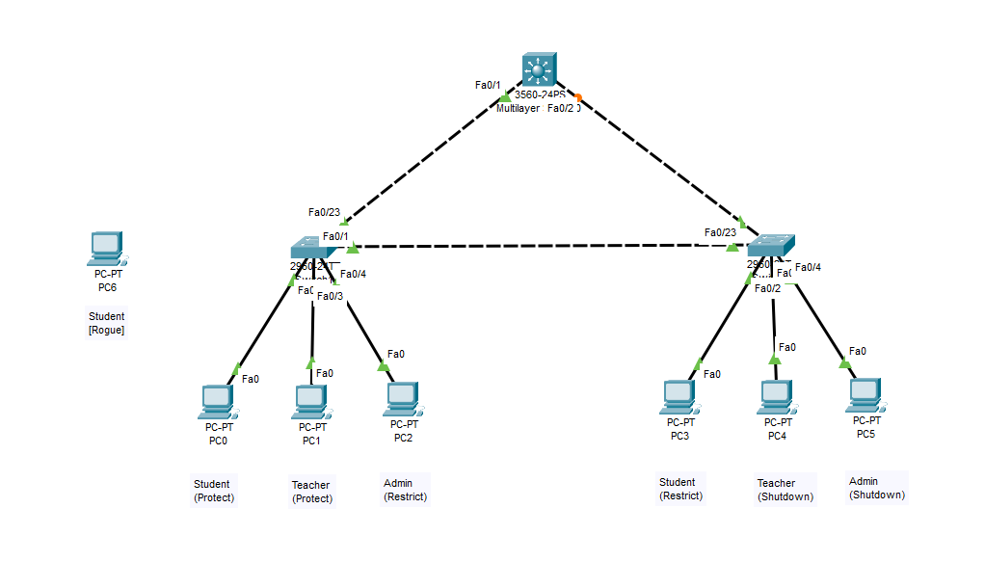

### **Working Procedure:**

* **Task 01:**

At first, I configured the PCs with valid IP according to the task.

For PCs connected to Switch 01,

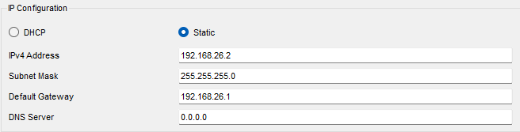

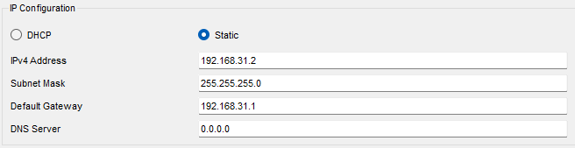

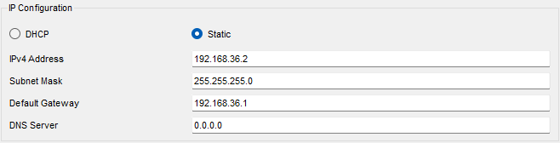

For PCs connected to Switch 02,

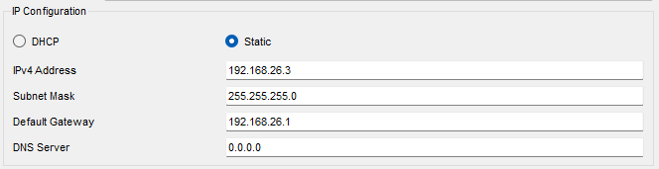

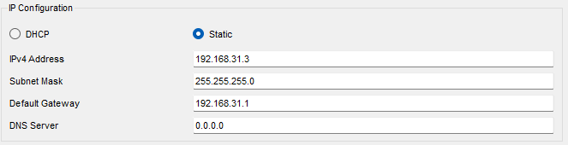

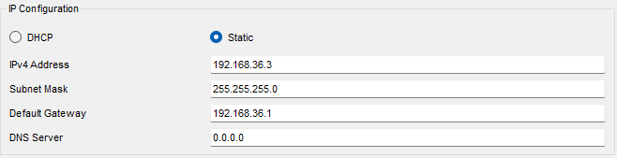

Then I implemented 3 VLANs – Student, Teacher & Admin for all the switches.

For Switch 01,

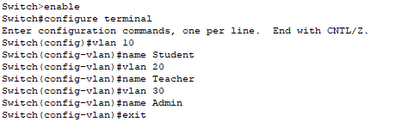

For Switch 02,

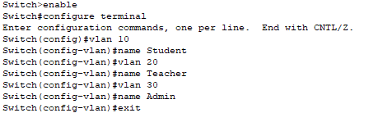

For L3 Switch,

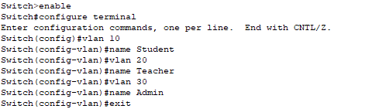

Then I configured the connecting ports to normal switches as access or trunk link accordingly.

For Switch 01,

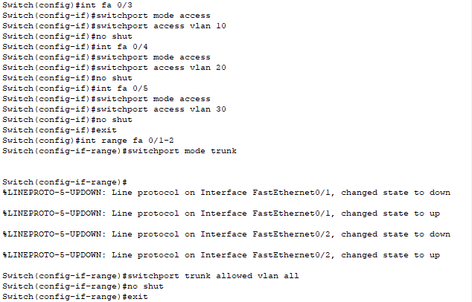

For Switch 02,

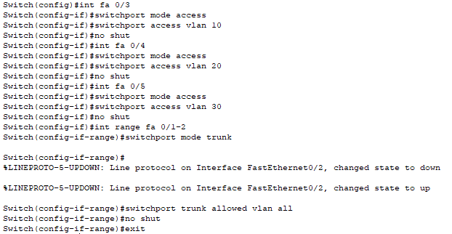

Then I configured the connecting ports to the L3 switch and assigned IP addresses for the VLANs.

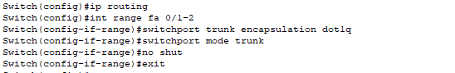

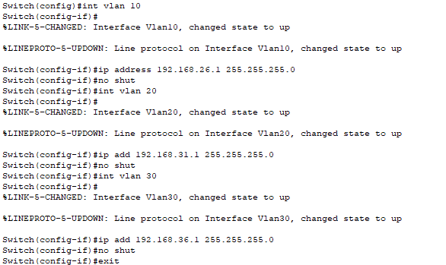

Then I configured the port security on the switches making 2 ports as Protect, 2 ports as Restrict and 2 ports as Shutdown.

For Switch 01,

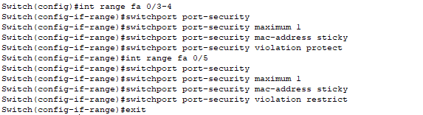

For Switch 02,

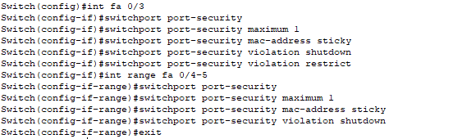

And also configured a rogue PC to test the port security.

* **Task 02:**

Initially, I configured SPAN for the Student on the switch 01 reporting to the Admin of the same switch and the Teacher on the switch 02 reporting to the Admin of the same switch.

For Switch 01,



For Switch 02,



### **Observation**:

* **Task 01:**

When I connect the rogue PC to the network and send a packet through the port that is set to “Protect”, the port will block the rogue PC without causing any disruption to the rest of the network.

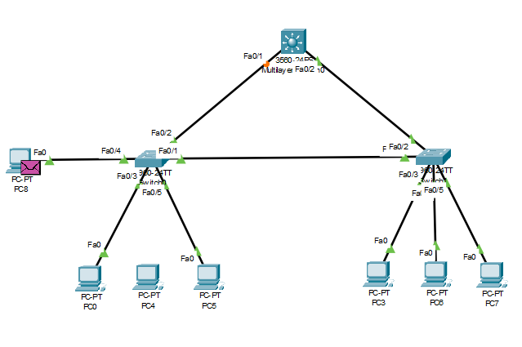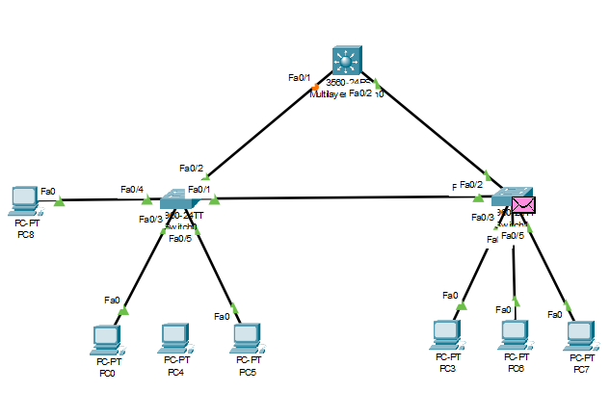

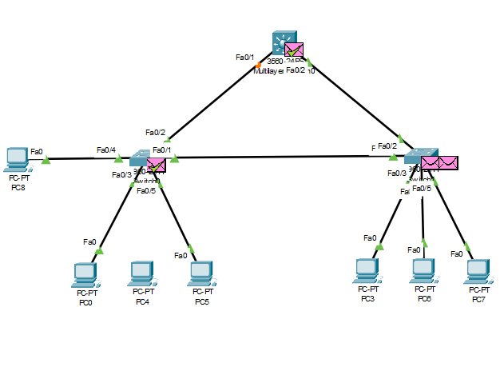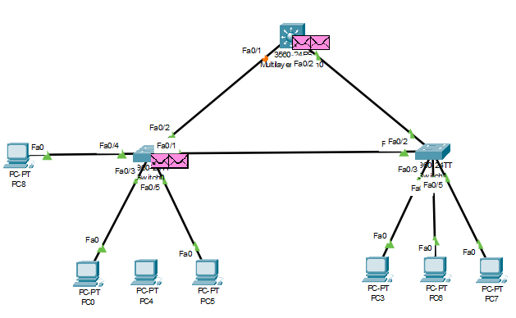

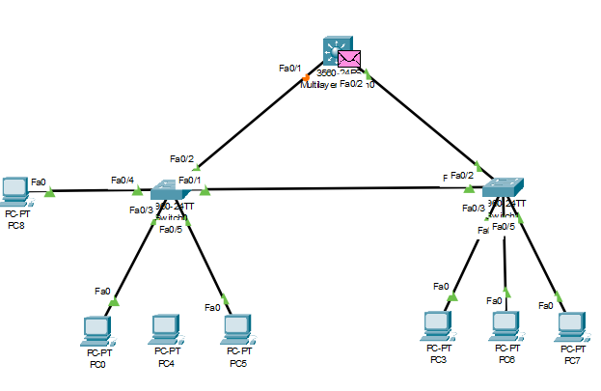

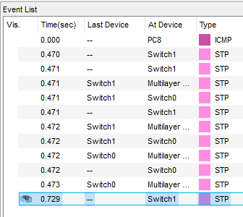

When I connect the rogue PC to the network and send a packet through the port that is set to “Restrict”, the rogue PC might be able to send some traffic, but it will be restricted.

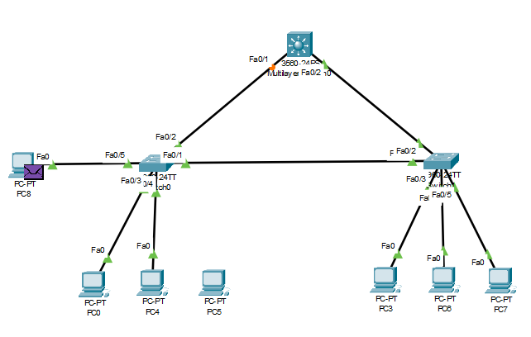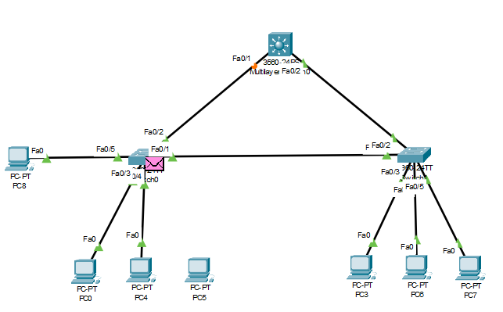

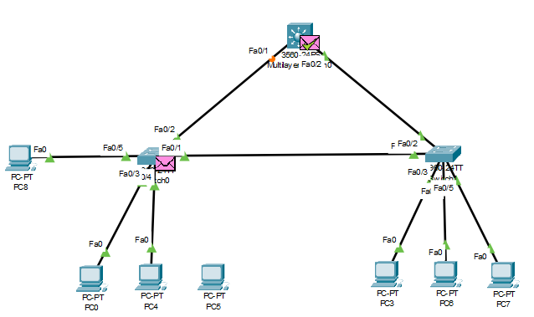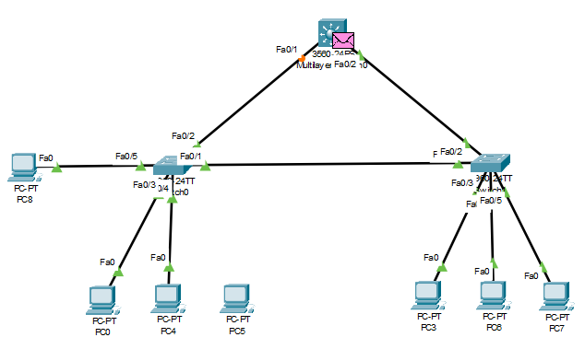

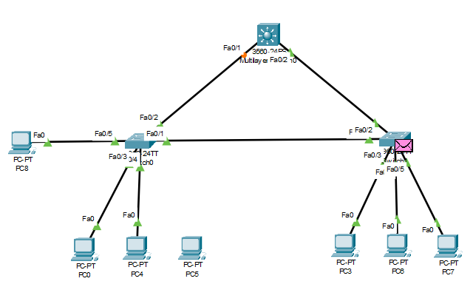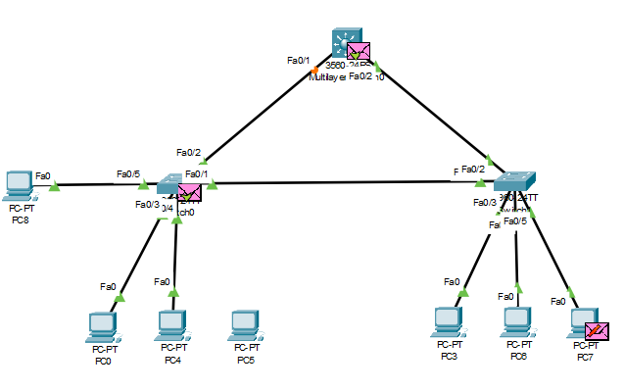

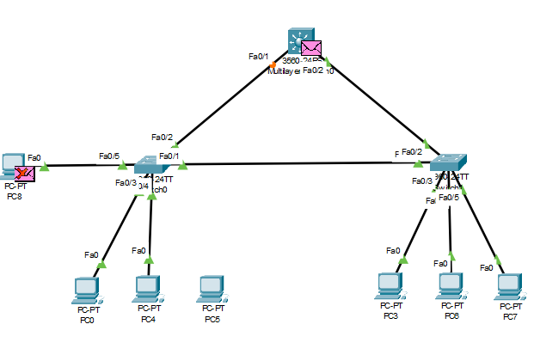

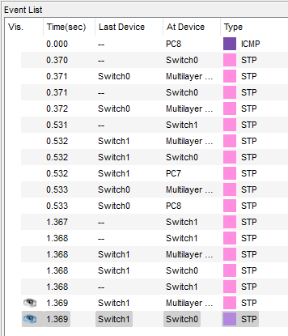

When I connect the rogue PC to the network and send a packet through the port that is set to “Shutdown”, the rogue PC should be shut down, isolating the rogue PC from the network. The rogue PC will not have network access.

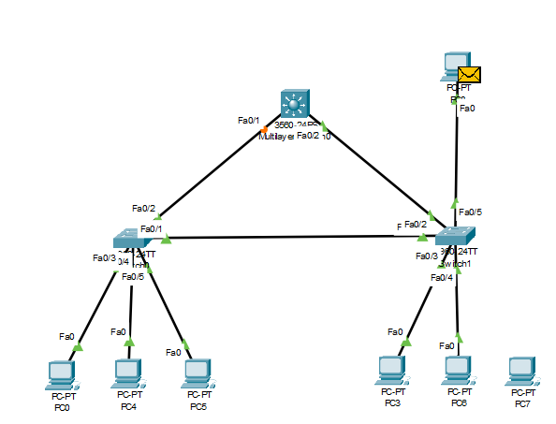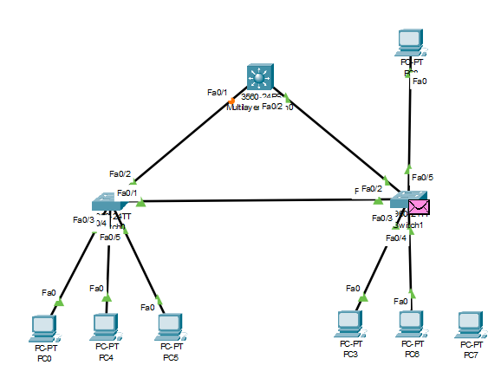

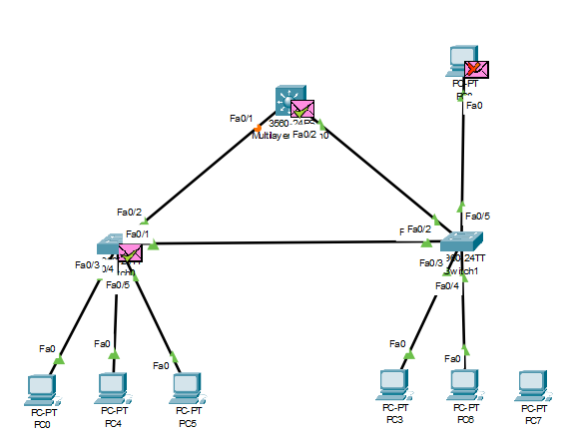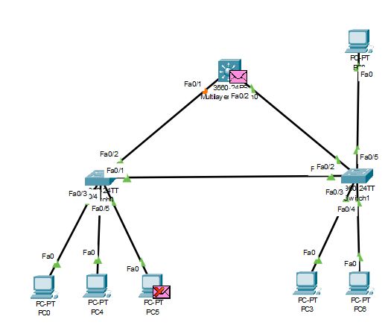

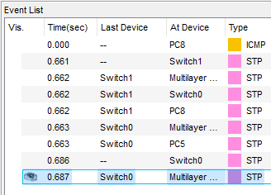

* **Task 02:**

SPAN Configuration for Student Ports (Switch A):

* + When you configure SPAN on the two ports where students are connected on Switch A, it will mirror the traffic from those student ports to the designated monitoring port.
  + The admin on Switch A will be able to monitor the communication of students, which could include the traffic between students themselves and their interaction with other devices.
  + It's essential to ensure that the monitoring port chosen on Switch A is correctly connected to the admin's monitoring device (e.g., a network sniffer or security tool).

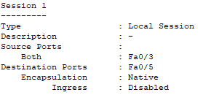

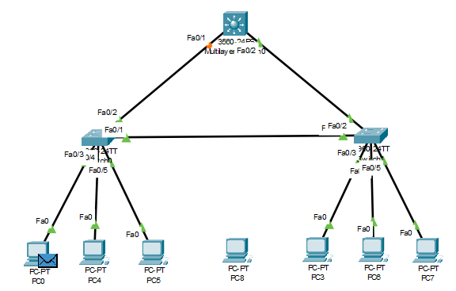 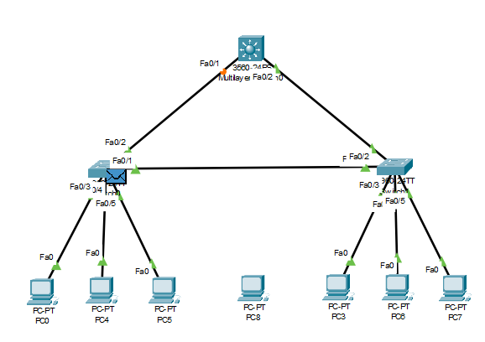

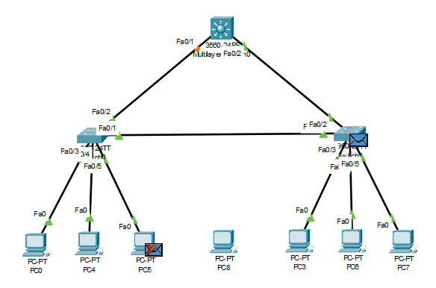 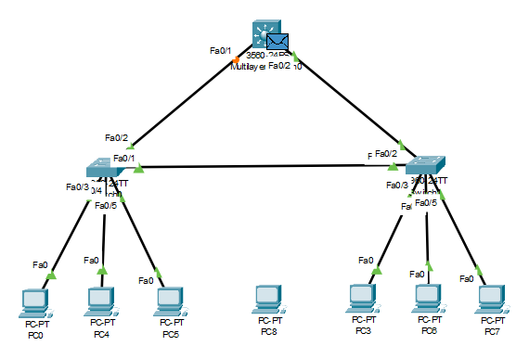

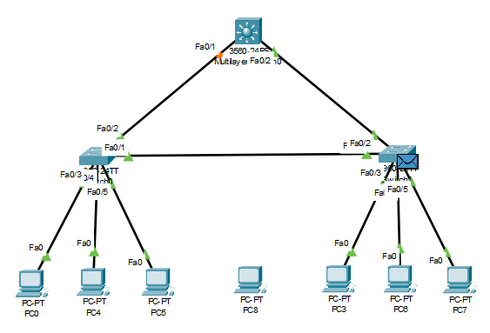 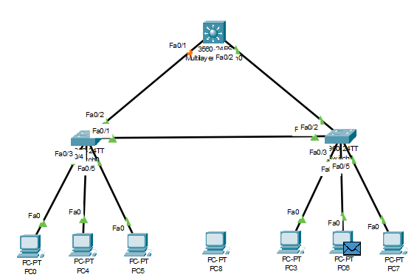

SPAN Configuration for Teacher Ports (Switch B):

* + Similarly, when you configure SPAN on the two ports where teachers are connected on Switch B, it will mirror the traffic from those teacher ports to the designated monitoring port.
  + The admin on Switch B will be able to monitor the communication of teachers, including their interactions with other devices and any communication among teachers.
  + Again, it's crucial to ensure that the monitoring port on Switch B is correctly connected to the admin's monitoring device.